Mechanical instructions

1. Linear actuators

**Timing:** 3h

**Materials**: As listed in the kit documentation

**Equipment:** M5 Allen key, spanners

**Critical:** Make sure the gantry plates are properly assembled to maximise stability of the moving components.

Assembly of the linear stages was completed according to the step-by-step instructions1 provided by OpenBuilds. The assembled 3-axis linear actuator system is shown in **Figure 1**:

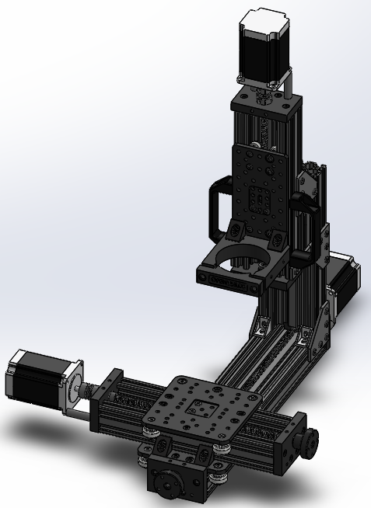

**Figure 1**. Finalised assembly of the 3-axis linear actuator system. The build includes 3 servo stepper motors, a gantry cart moving in x- and y- directions, printhead holder moving in the z-direction.

1 <https://openbuilds.com/builds/openbuilds-minimill.5087/>

1. Print bed

**Timing:** 0.5h

**Materials:** Gantry plate, Aluminium collector plate, screws (M5, M4), aluminium spacers.

**Equipment:** M4, M5Allen keys.

**Critical:** Screws used to fix the Aluminium collector plate need to be countersunk.

A print bed consists **(Figure 2C)** of an Aluminium collector plate (**Figure 2A**) and gantry cart (**Figure 2B**). It was designed to provide a simple collection system of MEW fibres while offering flexibility for potential print bed upgrades such as different collector geometry.

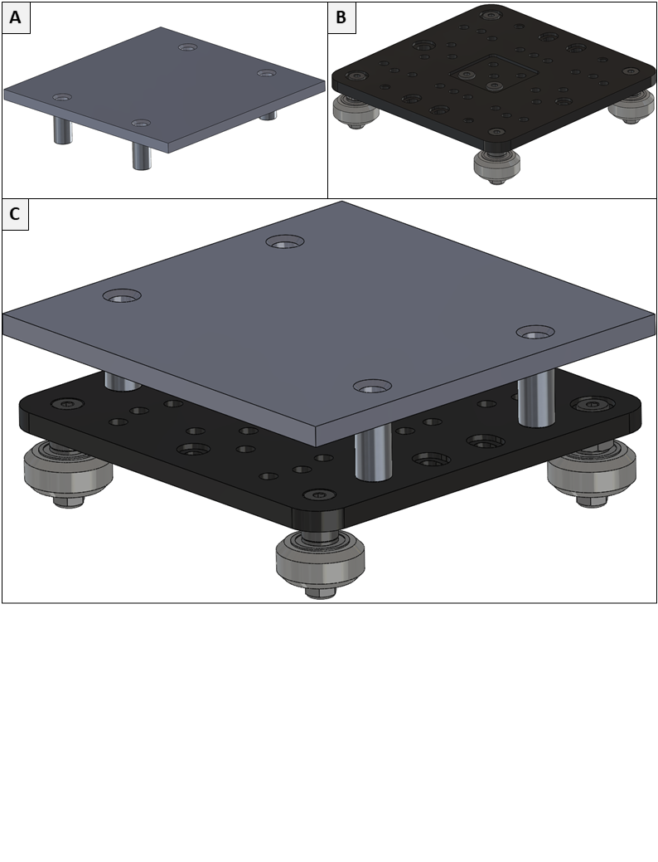

**Figure 2**. Collection system assembly. **(A)** The aluminium collector plate and **(B)** gantry cart are connected using M5 screws. Aluminium spacers used to adjust the height of the collector plate. Together, they form **(C)** an adjustable print bed.

1. Feed four M5 screws through the dedicated holes in the Aluminium collector plate.
2. Place Aluminium spacers around the screws.
3. Mount the Aluminium collector plate onto the gantry cart using the threaded screw holes in the gantry plate.
4. Printhead

**Timing**: 1h

**Materials**: Nozzle heater, syringe heater, Teflon printhead parts, brass ring, thermocouples, M5x30 cap screws, wing nuts, Nylon countersink screws, Nylon hex head screws, high voltage connector.

**Equipment:** Flat head screwdriver, scalpel blade.

**Critical**: Make sure the nozzle thermocouple is fed all the way to the bottom so it is in contact with the nozzle heater. Similarly, make sure the syringe thermocouple is fed halfway to the bottom through the dedicated hole.

The printhead provides storage for material used during the printing process while maintaining desired material temperature via heating elements.

1. Prepare the nozzle heater (**Figure 3A**).
2. Prepare the syringe heater (**Figure 3B**).
3. Fit the nozzle heater into the bottom part of the printhead (**Figure 3C**).
4. Cut and place five layers of Kapton tape on the nozzle heater to protect the heating element from high voltage (**Figure 3D**).
5. Fit the syringe heater into the hollow cavity of the printhead (**Figure 3E**).
6. Feed K-type thermocouples through the holes in the syringe and nozzle heating element (**Figure 3F**).
7. Fit the brass plate and Teflon insert into the additional part of the printhead and connect the high voltage connector (**Figure 4G**).
8. Connect both parts of the printhead together using Nylon screws (**Figure 4H**).
9. Place two M5 cap screws (**Figure 4I**).
10. Mount the acrylic attachment onto the main printhead body using Nylon screws (**Figure 4J**).
11. Prepare a syringe with material and connect an adaptor supplying air pressure. Place the syringe inside the printhead (**Figure 4K**).
12. Lock the syringe inside the printhead using 3D printed bracket and wing nuts (**Figure 4L**).

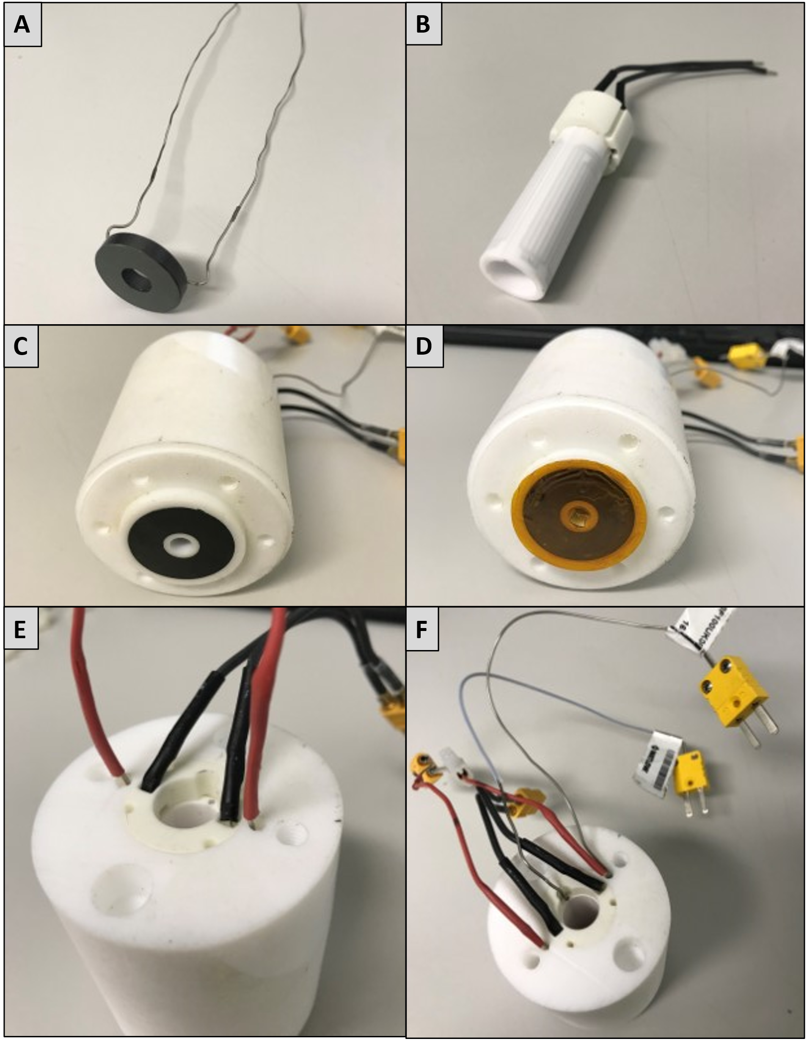

**Figure 3**. Printhead assembly process. Parts: **A)** nozzle heater, **B)** syringe heater, **C)** printhead with a nozzle heater, **D)** Kapton tape, **E)** syringe heater, **F)** k-type thermocouples.

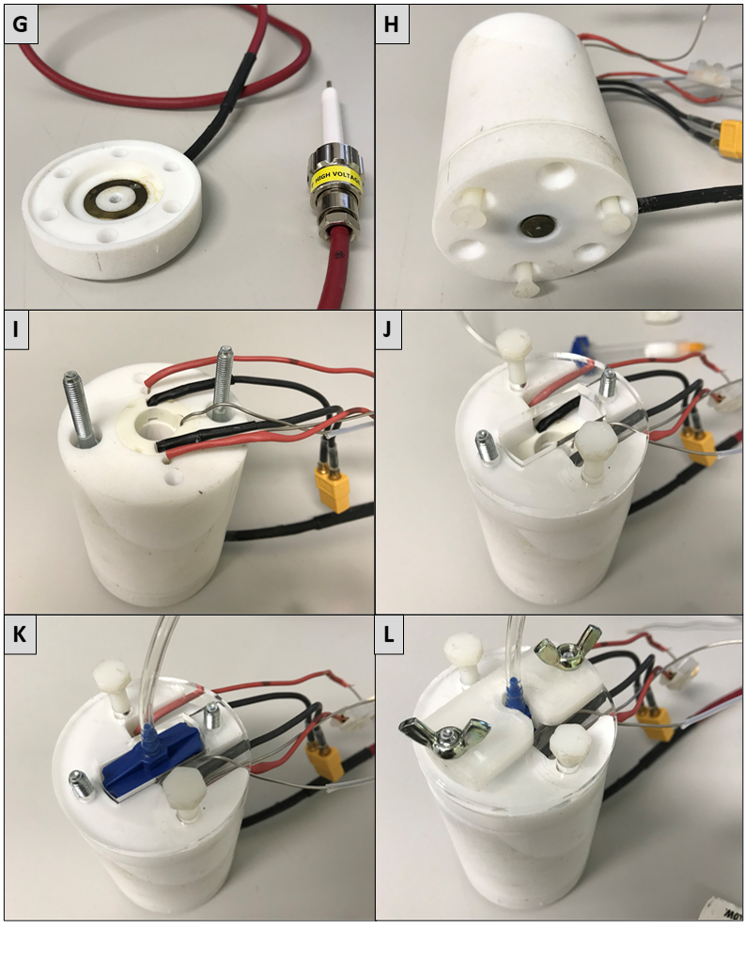

**Figure 4**. Printhead assembly process. Parts: **G)** Bottom part of the printhead, brass ring and high voltage connector, **H)** bottom part of the printhead attached to the main printhead body using Nylon screws, **I)** M5 cap screws, **J)** Acrylic top part of the printhead, **K)** syringe filled with material, air adaptor and air hose, **L)** 3D printed bracket with wing nuts securing the syringe.

1. Framework

**Timing:** 3h

**Materials:** Corner brackets, 30x30 aluminium profiles, 20x20 aluminium profiles, 20x80 aluminium profiles, M5 hammer nuts and M6 nuts, latching magnets**,** door handles, laser cut parts.

**Equipment:** M6 and M5 Allen keys, spirit level.

**Critical:** Make sure that corner brackets fit well with the adjacent panels to achieve solid and robust construction.

The framework consists of 30x30mm and 20x20 aluminium extrusion profiles connected using corner brackets. The top section consists of sensors and actuators mounted directly to the framework, while the bottom section consists of electrical components assembled on an Aluminium plate and two gantry plates.

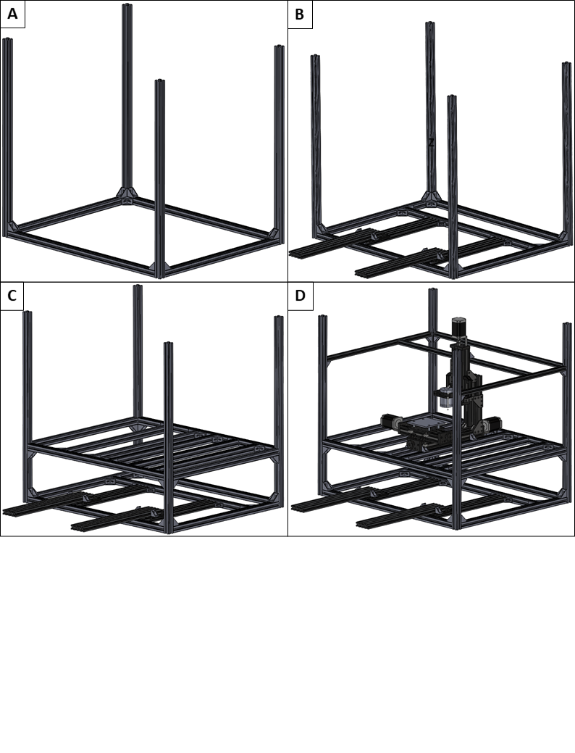

**Figure 5**. Framework assembly process. **A)** Assembly of a base frame with **(B)** sliding gantry system. **(C)** Complete electrical section, **(D)** printing section with assembled linear actuators, a print bed and a printhead.

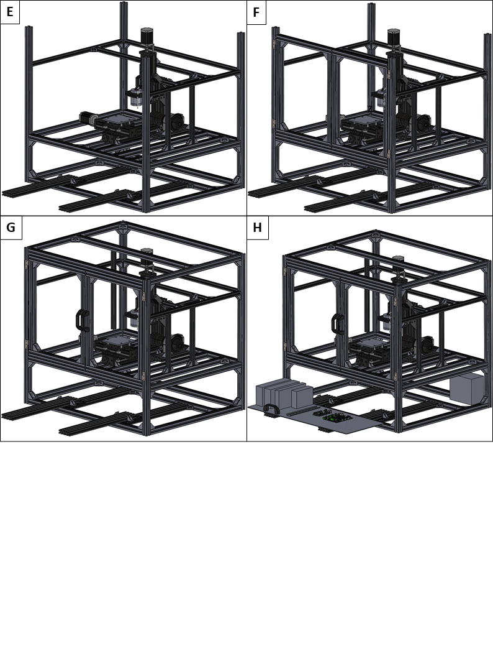

**Figure 6**. Framework assembly process. **E)** Assembled lens support, **F)** main door, **G)** top section of the framework and **H)** electrical Aluminium platform.

1. Connect the base of the frame using six 850mm and two 680mm 30x30 aluminium profiles (**Figure 5A**).
2. Follow OpenBuilds instructions1 to assemble two gantry carts.
3. Use four 80x20 profiles to fit two gantry carts from step 2)
4. Use a 30x30 profile and to complete the base of the frame (**Figure 5B**).
5. Attach nine 30x30 profiles (**Figure 5C**).
6. Attach linear stages system developed in 1).
7. Attach four 20x20 profiles (**Figure 5D**).
8. Assemble and attach vision support (**Figure 6E**).
9. Use eight 30x30 profiles, hinges and door handles to construct a pair of doors.
10. Attach the door to the frame (**Figure 6F**).
11. Use four 30x30 profiles to finish the top part of the framework (**Figure 6G**).
12. Use an acrylic panel, hinges and a door handle to construct an electrical door.
13. Attach four pairs of magnets to construct latches for the electrical and main door.
14. Attach silicone bumpers on the inside of the electrical door.
15. Attach Aluminium platform with electrical components (**Figure 6H**).
16. Final step

**Timing:** 3h

**Materials:** Printhead, printhead clamp, pressure regulator, pressure sensor, high voltage unit, thermocouple and thermocouple connectors, camera, lens, lens clamp, non-contact magnetic switches, laser-cut enclosure acrylic panels.

**Equipment:** M5 Allen key,

**Critical:**

In the last step, we finalise mechanical assembly by mounting a print bed, printhead, electrical components and acrylic panels.

1. Fix the printhead using a custom-made clamp (**Figure 7A**).
2. Attach thermocouple connectors (**Figure 7B**).
3. Connect a T-connector to the pressure sensor and mount it to the z-axis gantry cart using (**Figure 7C**)
4. Mount the pressure regulator to the framework using an acrylic bracket. Connect the inlet of the external air supply and the outlet to the T-connector of the pressure sensor (**Figure 7D**).
5. Connect the T-junction outlet of the pressure sensor to the syringe.
6. Attach the HV unit (**Figure 8E**).
7. Connect high voltage output lead with the HV cable of the printhead.
8. Secure the connection using electrical tape and attach an HV connector to the frame (**Figure 8F**).
9. Mount the camera and lens using c-mount and fix the monitoring device using a lens mount (**Figure 8G**).
10. Attach non-contact safety switches (**Figure 8H**).
11. Attach inner acrylic panels separating electrical and printing sections (**Figure 9I**).
12. Attach acrylic door of the electrical drawer and outer enclosure acrylic panels (**Figure 9J**).

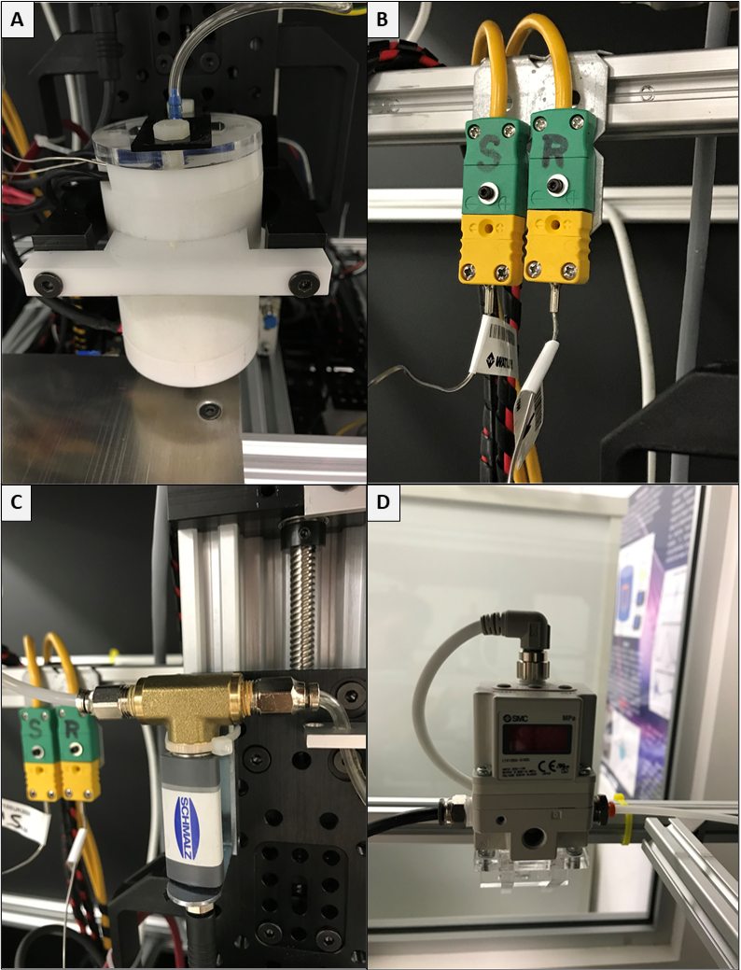

**Figure 7**. Final assembly process. **A)** Mounted printhead, **B)** connected thermocouples, **C)** pressure sensor, **D)** pressure regulator.

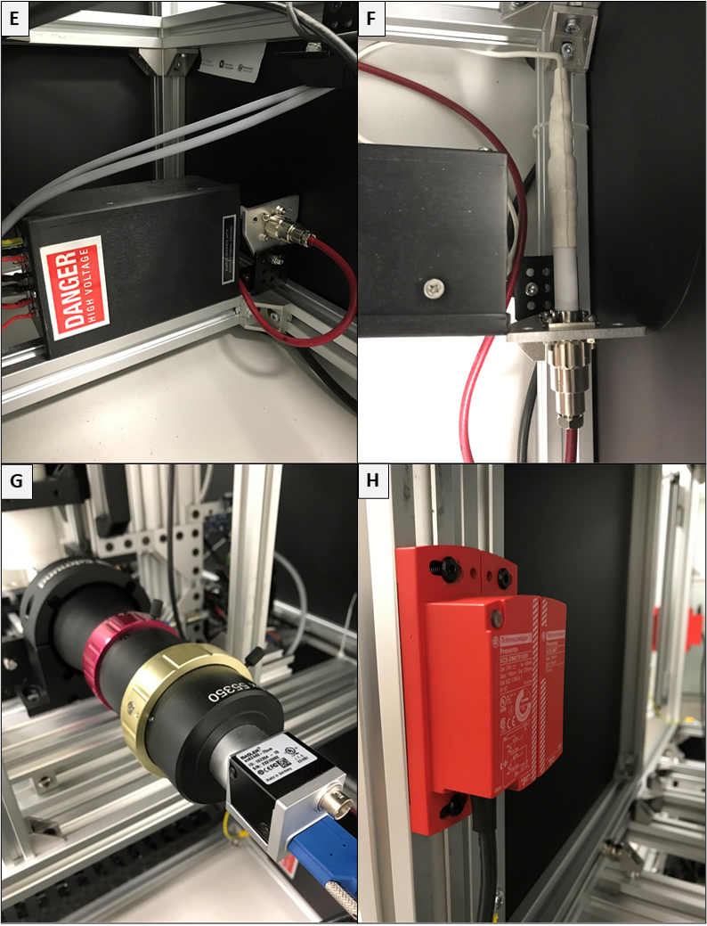

**Figure 8**. Final assembly process. **E)** High voltage unit, **F)** high voltage connector, **G)** Camera, lens and lens mount, **H)** non-contact magnetic switch.

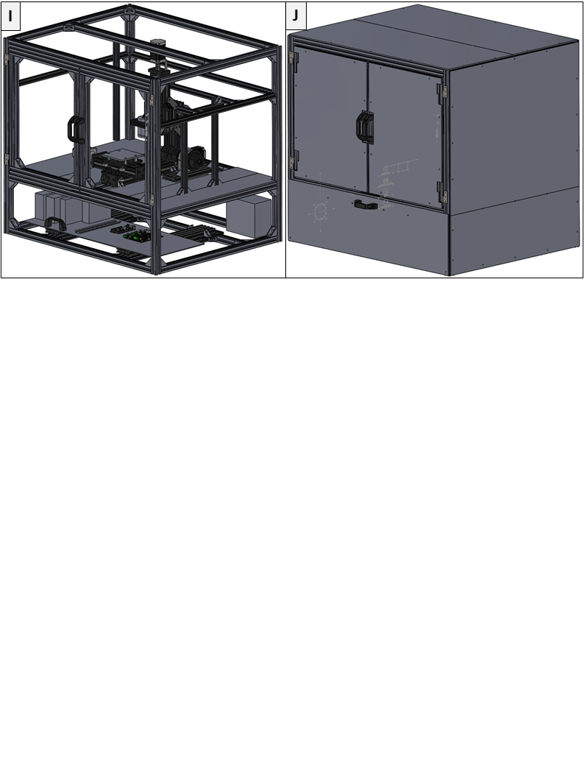

**Figure 9**. Final assembly process. **I)** Framework with acrylic panels separating electrical section from printing section and **J)** fully enclosed MEW platform.